**Topics: Descriptive Statistics and Probability**

1. Look at the data given below. Plot the data, find the outliers and find out $μ, σ, σ^{2}$

|  |  |
| --- | --- |
| **Name of company** | **Measure X** |
| Allied Signal | 24.23% |
| Bankers Trust | 25.53% |
| General Mills | 25.41% |
| ITT Industries | 24.14% |
| JPMorgan & Co. | 29.62% |
| Lehman Brothers | 28.25% |
| Marriott | 25.81% |
| MCI | 24.39% |
| Merrill Lynch | 40.26% |
| Microsoft | 32.95% |
| Morgan Stanley | 91.36% |
| Sun Microsystems | 25.99% |
| Travelers | 39.42% |
| US Airways | 26.71% |
| Warner-Lambert | 35.00% |

ANS: 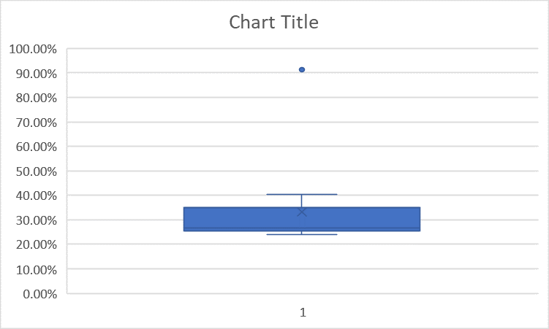



2.



Answer the following three questions based on the boxplot above.

1. What is inter-quartile range of this dataset? (please approximate the numbers) In one line, explain what this value implies.
2. What can we say about the skewness of this dataset?
3. If it was found that the data point with the value 25 is actually 2.5, how would the new boxplot be affected?

ANS: (i) Inter Quartile Range is between 5 and 12. IQR is Q3 – Q1 , i.e. 12-5 = 7. Hence 50% of data lies between upper and lower inter quartile range.

(ii) The dataset is positively skewed.

(iii) If 2.5 is the new data point to be added then there would be no outlier, for which the mean and median needs to be calculated to understand the change in the new box plot.

3.



Answer the following three questions based on the histogram above.

1. Where would the mode of this dataset lie?
2. Comment on the skewness of the dataset.
3. Suppose that the above histogram and the box-plot in question 2 are plotted for the same dataset. Explain how these graphs complement each other in providing information about any dataset.

ANS: (i)The mode of this dataset lies between 4 and 10.

(ii) The dataset is positively skewed.

(iii) For both the plots, an outlier is observed at the same position i.e., at 25. ---

1. AT&T was running commercials in 1990 aimed at luring back customers who had switched to one of the other long-distance phone service providers. One such commercial shows a businessman trying to reach Phoenix and mistakenly getting Fiji, where a half-naked native on a beach responds incomprehensibly in Polynesian. When asked about this advertisement, AT&T admitted that the portrayed incident did not actually take place but added that this was an enactment of something that “could happen.” Suppose that one in 200 long-distance telephone calls is misdirected. What is the probability that at least one in five attempted telephone calls reaches the wrong number? (Assume independence of attempts.)

ANS: X = The probability of 1 call being misdirected out of 200

Probability of occurrence of X = 1/ 200

P(X) = 1/ 200

Probability of having at least one successful call will be = 1 – P(X)

= 1- 1/ 200

= 199/200

= 0.967

As mentioned, that each event is independent of one another event the probability will be = 1 – 0.967

= 0.02475

= 2% chance

1. Returns on a certain business venture, to the nearest $1,000, are known to follow the following probability distribution.

|  |  |
| --- | --- |
| x | P(x) |
| -2,000 | 0.1 |
| -1,000 | 0.1 |
| 0 | 0.2 |
| 1000 | 0.2 |
| 2000 | 0.3 |
| 3000 | 0.1 |

1. What is the most likely monetary outcome of the business venture?
2. Is the venture likely to be successful? Explain
3. What is the long-term average earning of business ventures of this kind? Explain
4. What is the good measure of the risk involved in a venture of this kind? Compute this measure

ANS: (i) The highest probability of occurrence is $2000 as the P(x) is 0.3

(ii) Here, if the rate == positive,

Then, (0.2 + 0.3 + 0.1 = 0.6 🡪 60%.

Hence, the venture to be successful is 60%.

(iii) The long-term average earning of Business Venture:

= (-2000* 0.1) + (-1000* 0.1) + (0 *0.2) + (1000 * 0.2) + (2000 *0.3) + (3000 * 0.1)

= (-200) + (-100) + 0 + 200 + 600 + 300

= 800

(iv) The good measure to evaluate risk involvement in a venture is by calculating mean, variance and standard deviation.

